DR+Account+Setup+-+Tasks+and+Checklist - Copy DR Account Setup - Tasks and Checklist
- Create CloudEndure Replication Subnet
- Create VPC Peering between DR to Production account for CloudEndure replication
  - Accept VPC peering in production account
  - Update CE replication Routing Table in DR with VPC Peering connection
  - Update application subnets routing tables in production with CE replication VPC Peering
- Verify and/or Execute “AWS-Runbook-AMS-AccountLevel-DR-Preparation-Steps” Runbook
- Create / Update CloudEndure IAM Role
- Verify enforcement of EC2 EBS Default Encryption with a CMK
- Deploy DR Inventory solution (Lambda & S3) / Execute "InventoryDocumentation" Runbook
- Deploy DR Inventory S3 Replication Monitoring Solution
- Setup CloudEndure Project for the Account
- Deploy CloudEndure Agent Installation SSM Solution
- Setup Custom AWS Backup Plan (If required)

It’s recommended to test end-to-end the above solutions after deploying them for every state/account, you can follow this document to learn more about how to test it.

Tasks Dependencies:
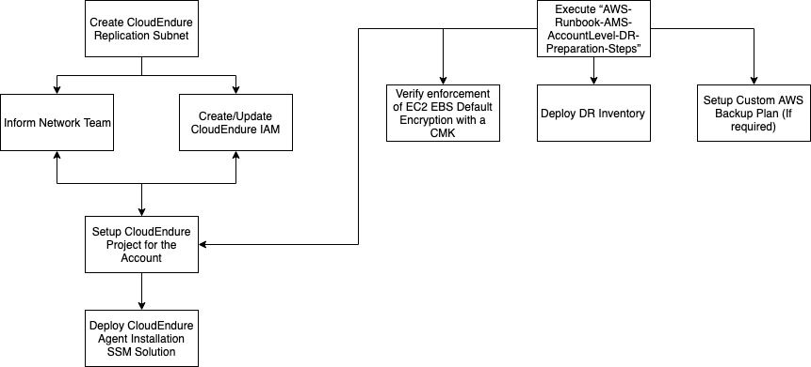

DR-Setup-Tasks.drawio

Create CloudEndure Replication Subnet
Pre-Requisite: None
RFC Change Type: Management, Other, Other (MOO)
Account: DR
ID: ct-1e1xtak34nx76
Subject: Add DR CE CIDR 10.134.128.0/23 Allocation to existing VPC
Comment: in the DR Account
- Add CIDR: 10.134.128.0/23 to existing VPC
- Create new route table and name it:
<AccountNumber>-ce-replication-<AZ_letter>
and add same routes available on application route table (you can refer to <EXISTING_ROUTING_TABLE_ID_SAME_AZ>)
- Create new subnet (Availability zone <EXISTING_AZ_LETTER> ) for the new 10.134.128.0/23.
Subnet name: <AccountNumber>-ce-replication-<AZ_letter>
attaching route table created in step 2.

Please make sure to replace the above angle bracket fields (<>) with the correct values:
- <ALLOCATED_CIDR_VALUE>- Check the correct subnet CIDR for the account you are working on (e.g. 10.134.106.0/23 for CS DR or 10.134.108.0/23 for FL DR), if you are not sure what should be the allocated CIDR value for your account reach to the DR team or to Paul St. (After conversation with George from networking team, we'll be using 10.134.128.0/23 across all DR accounts from now)
- <EXISTING_AZ_LETTER>- We want to use the same availability zone as one of the existing application subnets for the account that you are working on, so for example:
  - CS DR account have two application subnets, one in AZ (Availability Zone) A , and also in B, therefore we want to pick up either A or B AZ for the CE subnet.
  - FL DR account have two application subnets too, in AZs A and B, so we can choose either A or B here for the CE subnet.
- <EXISTING_ROUTING_TABLE_ID_SAME_AZ>- After you choose the AZ for the account that you are working on, we will also need to refer to existing routing table for AMS so they can create new routing table with the same settings.
In order to get the routing table ID, go to the AWS console and then go to the VPC dashboard, from there choose “Route Tables” on the left side panel, and look at the list of routing tables, you should see routing table for each application subnet for each AZ, example below:
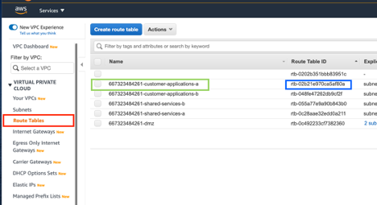
Pick up the “Route Table ID” value from the correct application subnet with the same AZ that we want to use for the CE subnet, see highlighted the Availability Zone A in this example.

Create VPC Peering between DR to Production account for CloudEndure replication
Pre-Requisite: None
Account: DR
RFC Change Type: Management, Other, Other (MOO)
ID: ct-1e1xtak34nx76

Subject: Create VPC Peering between DR and production
Comment: in the DR Account
"
Please create VPC Peering Connection:
From this DR account <DR_ACCOUNT_ID>, region <DR_REGION> (VPCID: <DR_VPC_ID>)
To production account <PRODUCTION_ACCOUNT_ID>, region <PRODUCTION_REGION> (VPCID: <PRODUCTION_VPC_ID>)
Tag VPC peering with Key=Name Value= <DR_ACCOUNT_ID>-ce-replication-peering
"
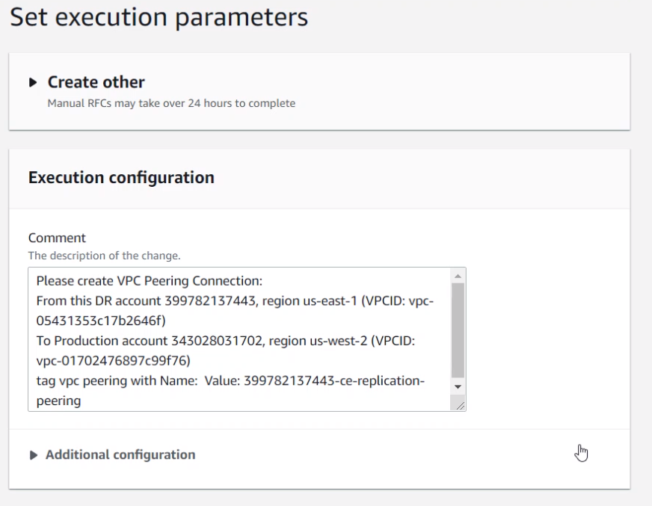

Accept VPC peering in production account
Pre-Requisite: Create VPC Peering between DR to Production account for CloudEndure replication
Account: Production
RFC Change Type: Management, Other, Other (MOO)
ID: ct-1e1xtak34nx76

Subject: Accept DR CE replication VPC peering
Comment:
"
Please refer to <DR_VPC_PEERING_RFC_ID>.
Please accept the VPC peering requested to this account from the RFC mentioned above.
"

Update CE replication Routing Table in DR with VPC Peering connection
Pre-Requisite: Accept VPC peering in production account
Account: DR
RFC Change Type: Management, Other, Other (MOO)
ID: ct-1e1xtak34nx76

Subject: Update CE replication Routing Table in DR with VPC Peering connection
Comment: in the DR Account
"
Please update the routing table <CE_REPLICATION_ROUTING_TABLE_ID> with the following destination and targets:
Destination: <PRODUCTION_APPLICATION_SUBNET_CIDRS>
Target: <DR_CE_REPLICATION_VPC_PEERING_ID>
"

Update CE replication Routing Table in DR with Internet connection
We also need to edit the routing table to include an outbound connection to the Internet so the CE replication servers can talk to the CE service and get commands and configuration information.
For the target you need a NAT gateway ID – ideally it would be a nat gateway in the same availability zone as the CE subnet, but if there is not one, then any nat gateway will work, pick the first one in the list.

Pre-Requisite: Accept VPC peering in production account
Account: DR
RFC Change Type: Management, Other, Other (MOO)
ID: ct-1e1xtak34nx76

Subject: Update CE replication Routing Table in DR with Internet connection
Comment: in the DR Account
"
Please update the routing table <CE_REPLICATION_ROUTING_TABLE_ID> with the following destination and targets:
Destination: 0.0.0.0/0
Target: <NAT_GATEWAY_ID>
"

Update application subnets routing tables in production with CE replication VPC Peering
Pre-Requisite: Accept VPC peering in production account
Account: Production
RFC Change Type: Management, Other, Other (MOO)
ID: ct-1e1xtak34nx76

Subject: Update application subnets routing tables in production with CE replication VPC Peering
Comment: in the Production Account
"
Please update the routing tables <APPLICATION_SUBNET_1_ROUTING_TABLE_ID_1> <APPLICATION_SUBNET_2_ROUTING_TABLE_ID> with the following destination and targets:
Destination: 10.134.128.0/23
Target: <DR_CE_REPLICATION_VPC_PEERING_ID>
"

Verify and/or Execute “AWS-Runbook-AMS-AccountLevel-DR-Preparation-Steps” Runbook
Follow the AWS-Runbook-AMS-AccountLevel-DR-Preparation-Steps and verify if all the steps has been executed before on the account, if not please make sure to execute them.
The runbook includes the following tasks:
- Increase EBS snapshot limit
- Create CMK KMS keys for EBS & RDS
- Create IAM role for Lambda execution in source account (for snapshot sharing)
- Modify DR account KMS key policies to allow source account IAM principles.
- Request AMS to create Lambda DR pattern for snapshot sharing & tagging.

Create / Update CloudEndure IAM User
How do I know if I need to create or update the CloudEndure IAM User?
In the AWS console, go to services(1), type “IAM”, choose IAM and then click on users(2).
If you see an existing user with the naming convention “customer_dxc_cloudEndure_user_<account>_proddr> or any other cloudendure IAM user (should only have single user), it means that there’s existing user and you need to update the IAM role, otherwise you need to create one.
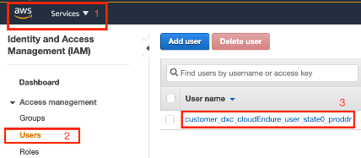

Create CloudEndure IAM User
Pre-Requisite: Execute “AWS-Runbook-AMS-AccountLevel-DR-Preparation-Steps” Runbook
RFC Change Type: Management, Other, Other (MOO)
ID: ct-1e1xtak34nx76
Subject:

Create CloudEndure IAM User

Comment:
Please create IAM User that will be used for CloudEndure disaster recovery. Reference the policy template from service request 7486861821 in account 942150623333. Be sure to update CloudEndure Replication Subnet ID in the resource section with one provided below for "ec2:RunInstances" action.

*Note in the account name use underscore “_” not a dash “-“ in the name. ex. amsconnecticut_stage)
- IAM username (customer_dxc_cloudEndure_user_<account-name>
- IAM policy name (customer_dxc_<account_name>_cloud_endure_user_policy),
- CLOUDENDURE_REPLICATION_SUBNET: (<CLOUDENDURE_REPLICATION_SUBNET>)
- KMS EBS Key ARN: <ARN KMS Key from Pre-Req Step>

Update CloudEndure IAM User
Pre-Requisite: Create CloudEndure Replication Subnet
RFC Change Type: Management, Other, Other (MOO)
ID: ct-1e1xtak34nx76
Subject: Update CloudEndure DR IAM Role Policy
Comment:
Please update IAM Policy <POLICY_NAME> with the CloudEndure DR Policy template which was pre-approved by AMS Security (please refer to service request 7486861821 for the template and AMS Security approval) Please replace the existing policy data with the new CloudEndure subnet below the “ec2:RunInstances" section in the policy template:
CLOUDENDURE_REPLICATION_SUBNET - <ce replication subnet id>

Verify enforcement of EC2 EBS Default Encryption with a CMK
This is a critical task - you MUST check that encryption is enabled by default with the correct key
How to check if Encryption is enabled by default for EC2?
In the AWS console, go to the EC2 dashboard, If using the classic EC2 console:
- On the EC2 Dashboard, under Account Attributes, select Settings.
else if using the new EC2 console:
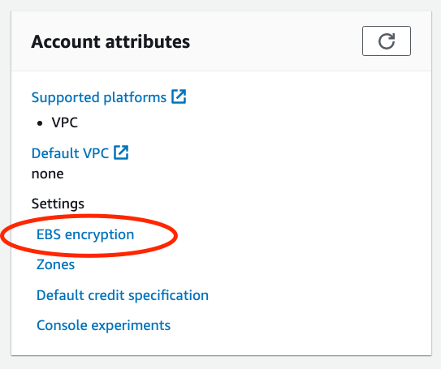
Verify that EBS encryption is enabled and using the right KMS key:
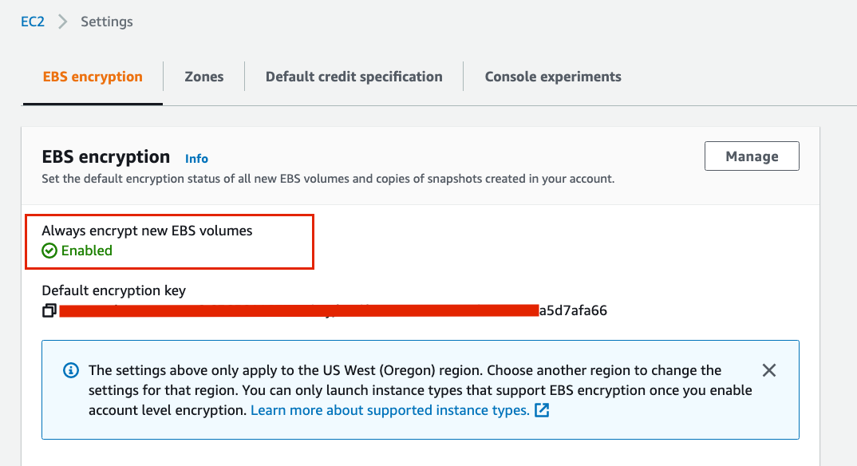

What is the "right" key?
For DR accounts, as for today, we are aligning to have a single KMS key (customer managed one aka as CMK), called " customer_dr_kms_key_ebs".
You might find that there is a CMK called "StagingEbsCmk" being used, we are not expecting to use and moving to use a single CMK key which suppose to be "customer_dr_kms_key_ebs" for the DR accounts only.
The key is incorrect or the default encryption is not enabled, how can I fix it?
Before creating RFC to fix the default encryption, you should check the following:
- Is the "customer_dr_kms_key_ebs" CMK key exists in the DR account? if not, it should be created as part of the on-boarding steps.
- Make sure the "customer_dr_kms_key_ebs" key policy contains the following policy scope:
This needs to be part of the KMS policy to ensure that the AMS resources that are running on the account will keep working properly and have access to use the default EC2 EBS encryption.
- {
- "Sid": "Allow access all principals in the account that are authorized to use KMS keys but with ec2 service condition",
- "Effect": "Allow",
- "Principal": {
- "AWS": "*"
- },
- "Action": [
- "kms:Encrypt",
- "kms:Decrypt",
- "kms:ReEncrypt*",
- "kms:GenerateDataKey*",
- "kms:CreateGrant",
- "kms:DescribeKey"
- ],
- "Resource": "*",
- "Condition": {
- "StringEquals": {
- "kms:ViaService": "ec2.<region>.amazonaws.com",
- "kms:CallerAccount": "<accountId>"
- }
- }
}
Make sure to replace <region> and <accountId> with the right values for the account that you are working on.
If you don't see the above policy scope as part of the "customer_dr_kms_key_ebs" key policy, you must add it by the relevant AMS RFC.
After you verified the above, proceed with requesting AMS RFC to set the default encryption with the right key - "customer_dr_kms_key_ebs".

Type: Manual Other Other (MOO)
Subject: Enable EC2 default encryption
Comment:
“
Please enable EC2 default encryption with the following key: <KMS_DR_EBS_KEY_ARN>
“

Deploy DR Inventory solution (Lambda & S3) / Execute "InventoryDocumentation" Runbook
Download from DXC DR Strategy in AWS Documents "InventoryDocumentation" doc
Note - If you have already deployed the inventory solution and want to redeploy it follow these steps.

Deploy DR Inventory S3 Replication Monitoring Solution
Pre-Requisite: Deploy DR Inventory Solution
Follow Instructions to the S3 Monitoring Replication Document

Setup CloudEndure Project for the Account

Follow AWS-Runbook-AMS-CloudEndure-DR-Operations-Steps
Make sure to enable notification while being logged in with the DR e-mail distribution list (HHS.DR.Engineers@dxc.com>) account, this is to allow receiving notification regards the project so the team can take immediate actions if needed (e.g. replication not working, network lost, big lag diff etc.)
See "How do I set up email notifications?" in https://docs.cloudendure.com/Content/FAQ/FAQ/Basic_Operations.htm for more info.

Deploy CloudEndure Agent Installation SSM Solution
Download from DXC DR Strategy in AWS Documents "DXC HCT – Automated Deployment of CloudEndure Agent" doc

Setup Custom DR AWS Backup Plan.
Download from DXC DR Strategy in AWS Documents For DR specific steps please follow "DXCHCT-Backup-Share-CrossRegion-EBS_v2.docx. For overall backup setup refer to "DXC-HCT-DR AWS BackupV1".
- For further testing after the DR AWS backup plan and vault is setup - you may use the AWS Backup script to ensure all instances indeed have recovery point in the DR vault from today's date.
- Please refer to the README.md file in the folder for further instructions how to run the script.

Verify ACM IAM Role created in DR account
Verify IAM role "customer_hhs_acm_admin_role" exists in the DR account, if it doesn't, you can create the following RFC:
§ RFC Change Type: Management, Other, Other (MOO)
ID: ct-1e1xtak34nx76
- Subject: Create new IAM role for customer ACM imports
- Comment: role name = customer_hhs_acm_admin_role. Copy policy for same IAM role in account 369000681707

